Digital Technology – Gambling Game Planning

**Neo Haggard 10.2**

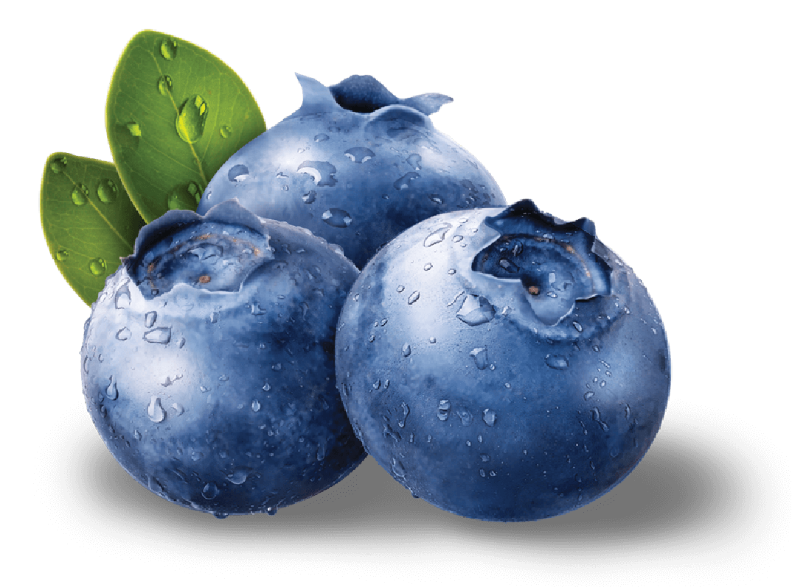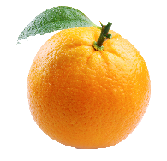

**Tracked Data**

|  |  |  |
| --- | --- | --- |
| **Data Tracked** | **Type** | **Comment** |
| Current Credits | Integer | Tracks the current amount of credits that the user possesses. |
| Total Spins | Integer | Tracks the current amount of spins that have been used. |
| Each Spin Result | Array Of Objects | Tracks each individual spin result. |
| Total Wins | Integer | Tracks the current amount of wins that a user possesses. |
| Total Losses | Integer | Tracks the current amount of losses that a users possesses. |

**PyBet**

2

10

**SPIN**

7

7

**Planned Design**